Student Name | G. Manasa
Student Registration Number | 241U1R3007 | Class &Section: DS-IIA
Study Level: UG/PG | UG | Year &Term: II & I
Subject Name | Digital Electronics

Name of the Assessment | Lab Report
Date of Submission | 17/08/2025

LAB REPORT-6
Simulation of Binary Adders and Binary Subtractors
Objective:
To design and simulate binary adders and binary subtractors using SimulIDE software and verify their truth tables.
Software Required:
PC with SimulIDE software installed
Theory:
1. Binary Adder
A Binary Adder is a digital circuit that performs addition of binary numbers.
- Half Adder: Adds two binary bits and produces Sum (S) and Carry (C).
  - Logic Equations:
    - Sum (S) = A ⊕ B
    - Carry (C) = A · B
- Full Adder: Adds three binary bits (A, B, and Cin) and produces Sum (S) and Carry (Cout).
  - Logic Equations:
    - Sum (S) = A ⊕ B ⊕ Cin
    - Carry (Cout) = (A · B) + (Cin · (A ⊕ B))

2. Binary Subtractor
A Binary Subtractor is a digital circuit that performs subtraction of binary numbers.
- Half Subtractor: Subtracts two bits and gives Difference (D) and Borrow (B).
  - Logic Equations:
    - Difference (D) = A ⊕ B
    - Borrow (B) = A′ · B
- Full Subtractor: Subtracts three bits (A, B, and Bin) and gives Difference (D) and Borrow (Bout).
  - Logic Equations:
    - Difference (D) = A ⊕ B ⊕ Bin
    - Borrow (Bout) = (A′ · B) + (Bin · (A′ ⊕ B))

Circuit Diagrams:
Half Adder
- It is an arithmetic combinational logic circuit designed to perform addition of two single bits.
- It contains two inputs and produces two outputs.
- Inputs are called Augend and Added bits and Outputs are called Sum and Carry.
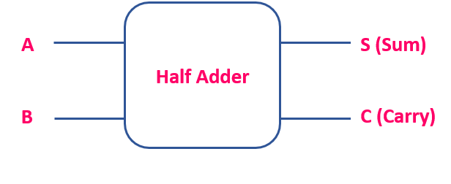
Truth Table of Half Adder:
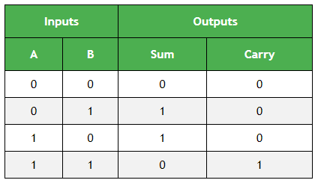
K-map for output variable Sum 'S':
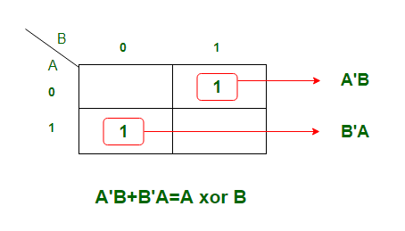
K-map is of Sum of products form. The equation obtained is
S = AB' + A'B
which can be logically written as,
S = A ⊕ B

K-map for output variable Carry 'C':
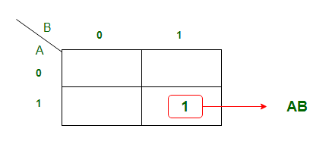
The equation obtained from K-map is,
C = AB
Using the Boolean Expression, we can draw logic diagram as follows..
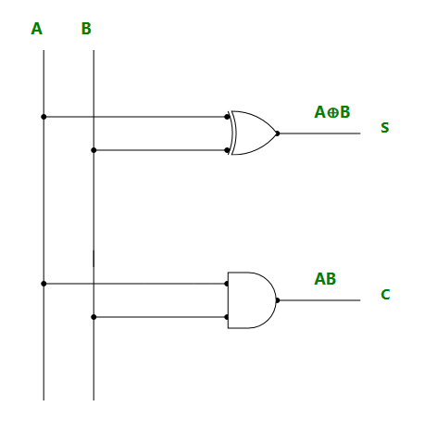

Simulation-
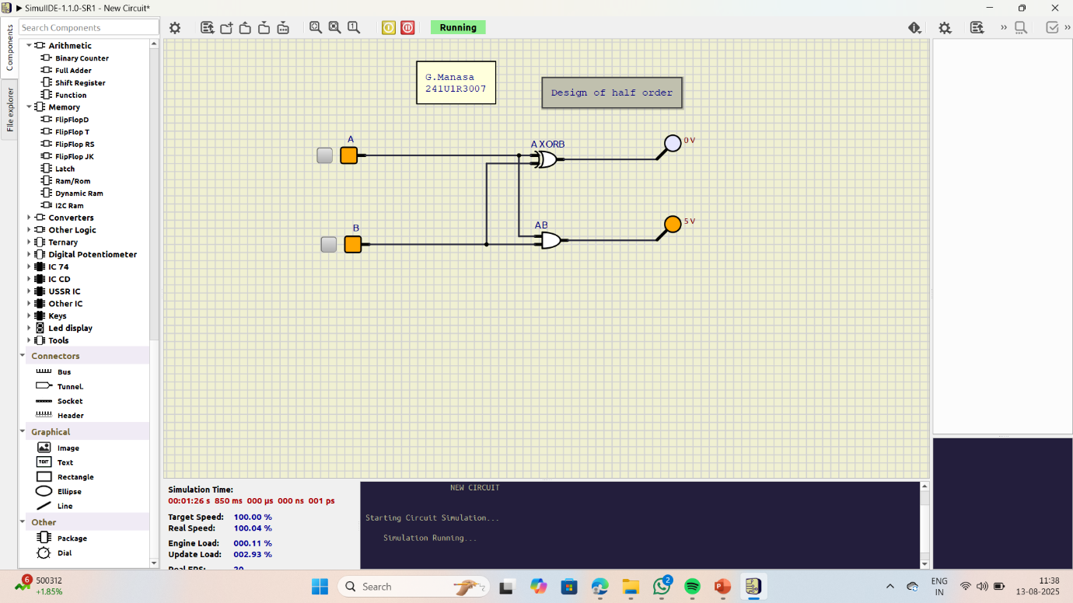

Full Adder
- It is a arithmetic combinational logic circuit that performs addition of three single bits.
- It contains three inputs (A, B, Cin) and produces two outputs (Sum and Cout).
- Where, Cin -> Carry In and Cout -> Carry Out
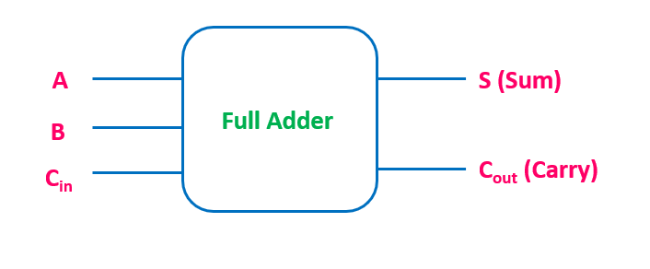

Truth table of Full Adder:
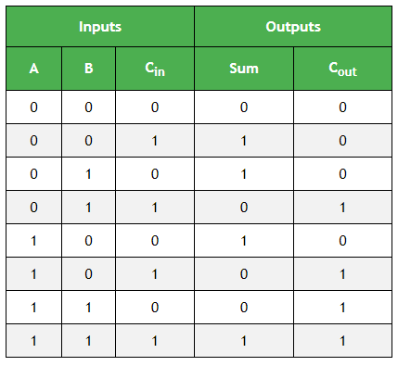
K-map Simplification for output variable Sum 'S' :
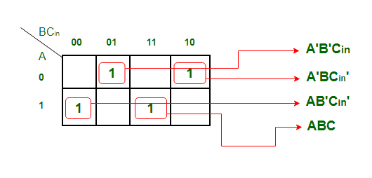
The equation obtained is,
S = A'B'Cin + AB'Cin' + ABC + A'BCin'
The equation can be simplified as,
S = B'(A'Cin+ACin') + B(AC + A'Cin')
S = B'(A xor Cin) + B (A xor Cin)'
S = A xor B xor Cin
K-map Simplification for output variable 'Cout'
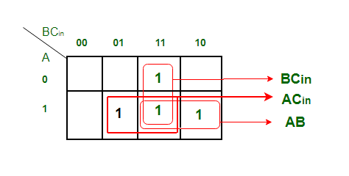
The equation obtained is,
Cout = BCin + AB + ACin
Logic Diagram of Full Adder
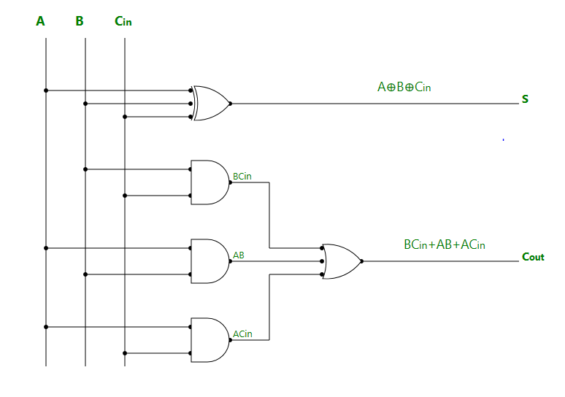
Simulation-
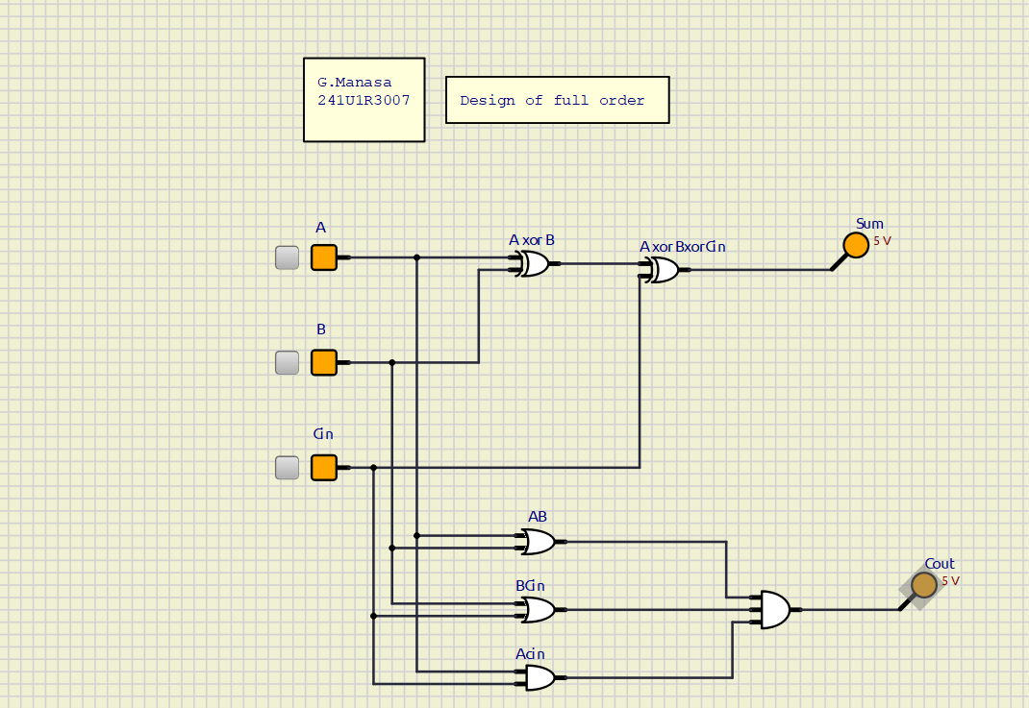

Full Adder Using Half Adders:
Full adder can also be implemented using two half adders and one OR gate.
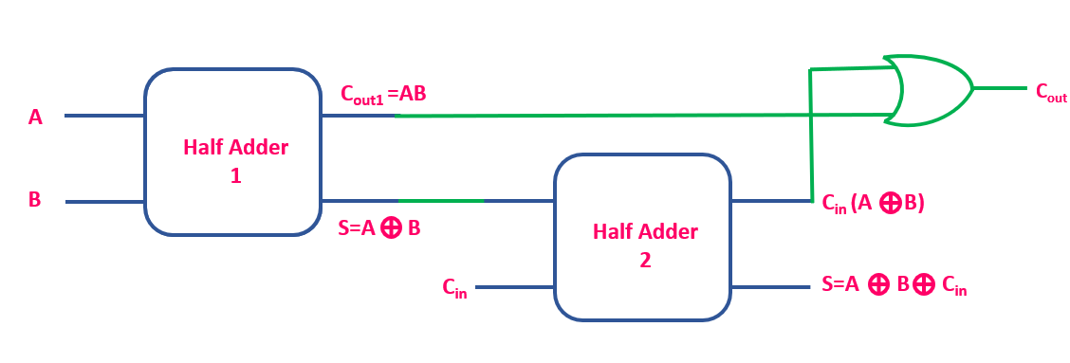
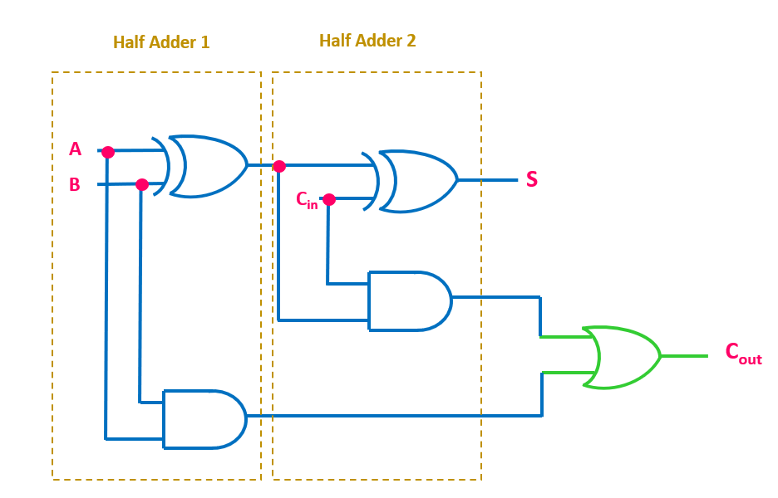
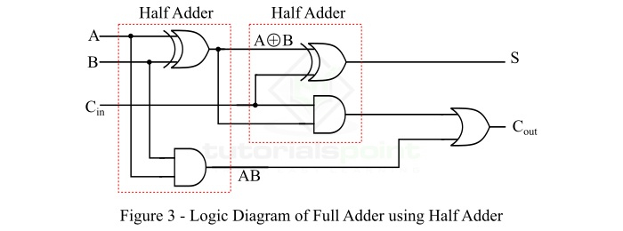
Simulation-
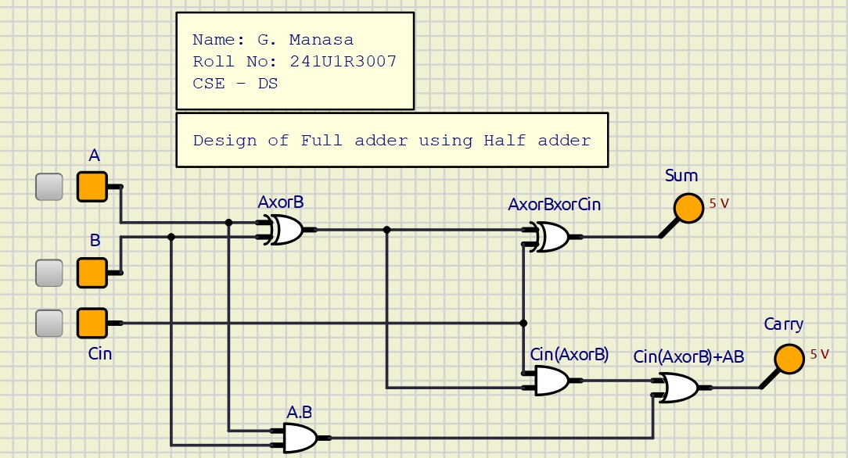

Half-Subtractor:
A half-subtractor is a combinational logic circuit that have two inputs and two outputs (i.e. difference and borrow). The half subtractor produces the difference between the two binary bits at the input and also produces a borrow output (if any). In the subtraction (A-B), A is called as Minuend bit and B is called as Subtrahend bit.
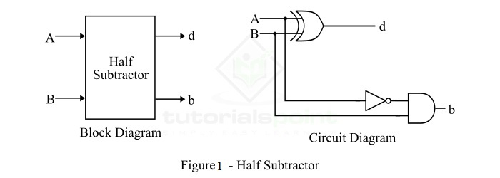
Truth Table of Half Subtractor
The following is the truth table the half-subtractor −

Inputs |  | Outputs
A | B | D (Difference) | B (Borrow)
0 | 0 | 0 | 0
0 | 1 | 1 | 1
1 | 0 | 1 | 0
1 | 1 | 0 | 0

The K-Map simplification for half subtractor is shown below
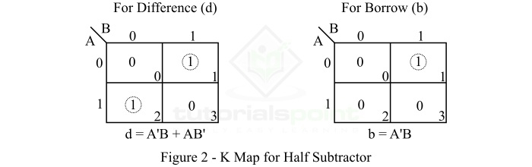
Simulation-
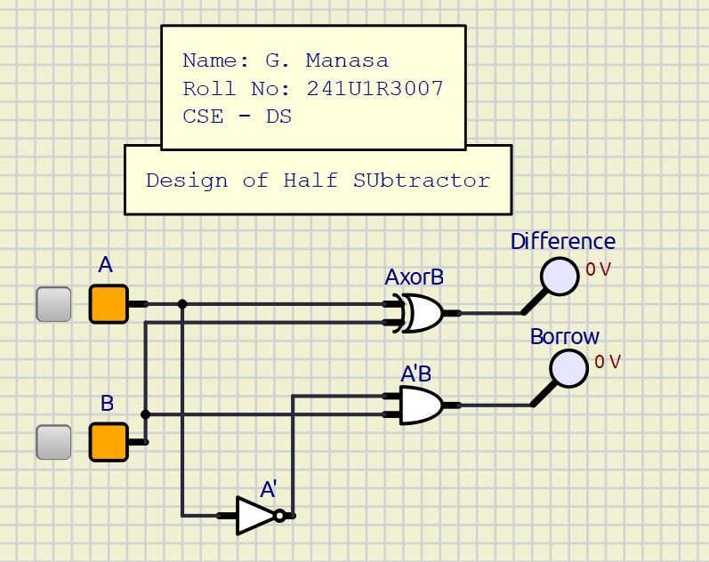
Full-Subtractor
A full-subtractor is a combinational circuit that has three inputs A, B, bin and two outputs d and b. Where, A is the minuend, B is subtrahend, bin is borrow produced by the previous stage, d is the difference output and b is the borrow output.
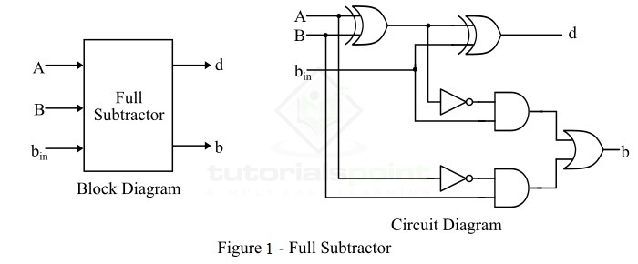
Truth Table of Full-Subtractor
Inputs |  |  | Outputs
A | B | B_{in} | D (Difference) | B (Borrow)
0 | 0 | 0 | 0 | 0
0 | 0 | 1 | 1 | 1
0 | 1 | 0 | 1 | 1
0 | 1 | 1 | 0 | 1
1 | 0 | 0 | 1 | 0
1 | 0 | 1 | 0 | 0
1 | 1 | 0 | 0 | 0
1 | 1 | 1 | 1 | 1

K-Map for Full Subtractor
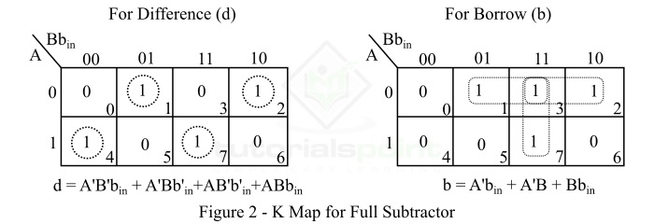
From the logic circuit diagram and k-map −
Difference,d=A⊕B⊕bin=A′B′bin+AB′b′in+A′Bb′in+ABbin

Borrow,b=A′B+(A⊕B)′bin

From Truth Table
Borrow,b=A′B′bin+A′Bb′in+A′Bbin+ABbin

Or
Borrow,b=A′B(bin+b′in)+(AB+A′B′)bin=A′B+(A⊕B)′bin

Simulation-
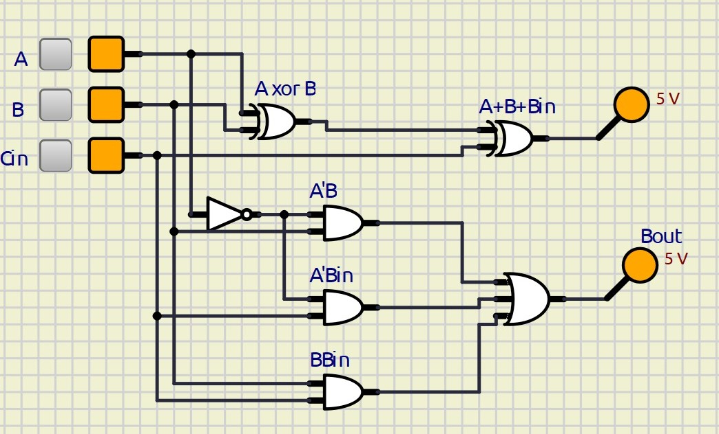

Full Subtractor using Half Subtractors
A full subtractor can be realized using two half subtractors. It will take two half-subtractors and one OR gate.
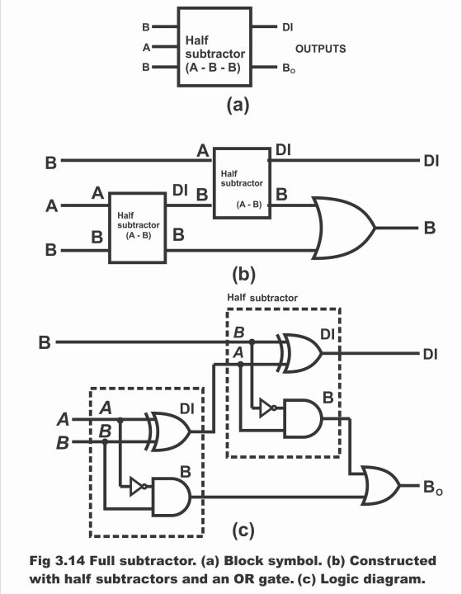

Simulation-
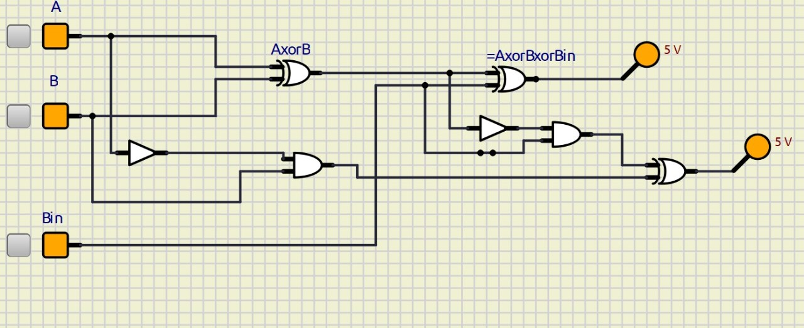
Result:
The Half Adder, Full Adder, Half Subtractor, and Full Subtractor were successfully designed and simulated using SimulIDE, and their truth tables were verified.

__Danke__

